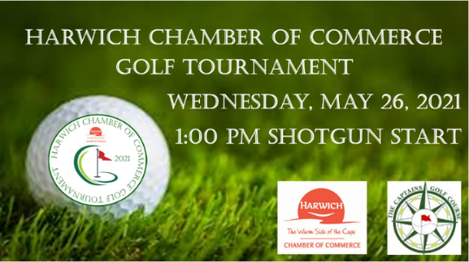
Harwich Chamber of Commerce Golf Tournament Sponsorship Levels

______Tournament Presenting Sponsor-$2500 (1 Available)
One Foursome (includes greens fee, cart and dinner)
Four hats for players
Banner at Registration Entrance, Opportunity for a table for your business at designated hole, Logo on all Promotional Information
Premium exposure on radio, print, website, and all social media outlets
Sponsorship recognition during event.
_______Gold Sponsor-$1500 (2 Available)
One Foursome (includes greens fee, cart and dinner)
Included in radio, print, website, and all social media outlets
Logo displayed on Event Signage
________Silver Sponsor-$1000(4 Available)
Two players (includes greens fee and cart and dinner)
Included in radio, print, website, and all social media outlets
Logo displayed on Event Signage.
________Bronze Sponsor-$500 (6 Available)
Included in radio, print, website, and all social media outlets
Logo displayed on Event Signage.
______Beverage Cart Sponsor- $400 (1 Available)
_________Hole Sponsor- $300 (18 Available)
Name of Business_______________________________
Contact:______________________________________
Email:________________Phone:__________________
Payment: Check ________Made payable to Harwich Chamber of Commerce
Credit Card #__________________________________ (exp)________ (code)_______

For more information contact Cyndi Williams at Cyndi@harwichcc.com or 508-430-1165

